EXERCISE 16
- List IDs, birth dates, and emails of employees born in April.
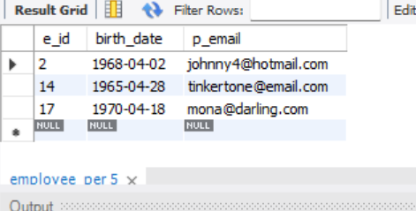
- Display IDs, birth dates, and spouse names of employees born in 1969 and sort the entries on the basis of their spouse names.
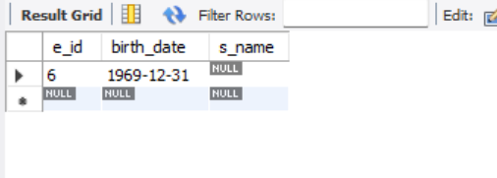
- List the employee IDs for employees born under the current month.
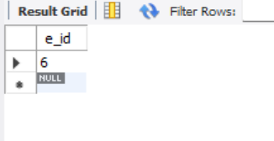

- How many unique birth years do we have?
12
- Display a list of unique birth years and the number of employees born under each.
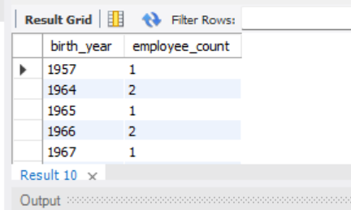
- How many employees were born under each month?
